GIT 
Linux Commands:
pwd: present working directory
cd: change directory Ex: cd ‘Rahul GIT’ or cd <folder name>
ls: list of files in current directory/folder
mkdir: make directory/folder Ex: mkdir <folder name>
touch <file_name>: to create a file in current working directory Ex: touch demo.txt
nano <file_name>: to access the file and do some changes Ex: nano demo.txt
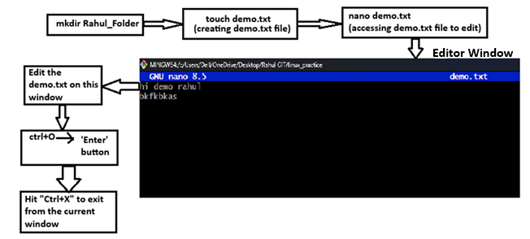
echo “<file-content-write>”> <file-name> : In single line creating file in current directory and write something
cat <file_name>: to check what is written in this file Ex: cat demo.txt
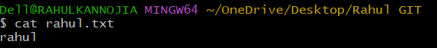
mv <file_name> <rename file_name>: generally used for renaming the filename
Ex: mv demo.txt demo1.txt
rm <file_name>: generally used to remove/delete the file from the directory Ex: rm demo.txt
rm –rf <folder/directory name>: remove or delete the folder/directory
VERSION CONTROL WITH GIT
Purpose of Version Control:
- History Tracking: Maintain a record of changes made to a project, including who made them, when, and what changed i.e., Traceability.Collaborate with others and helps in reviewing the code.
- Collaboration: Enable multiple developers to work on a project simultaneously, coordinating efforts and avoiding conflicts.
- Code Backup: Provide secure backups of project files to prevent data loss.
- Feature Development: Allow for the development of new features without impacting the main project.
- Code Review: Facilitate peer code review to ensure code quality and identify issues early.
GIT Introduction:
Git is an open-source distributed version control system that helps teams track and manage code changes, collaborate seamlessly, and work on projects of any size. It keeps a history of every change, allowing you to revisit or restore previous versions, and makes it easy to fix mistakes without losing progress.
- Git is a source code management software.
- Git is a command-line tool i.e., A software which is maintained by Linux.
- Git is Software but Github, Gitlab, Bitbucket, etc…are all Services.
- It is Distributed version control system, meaning that each user has a copy of the entire project history on their local machine.
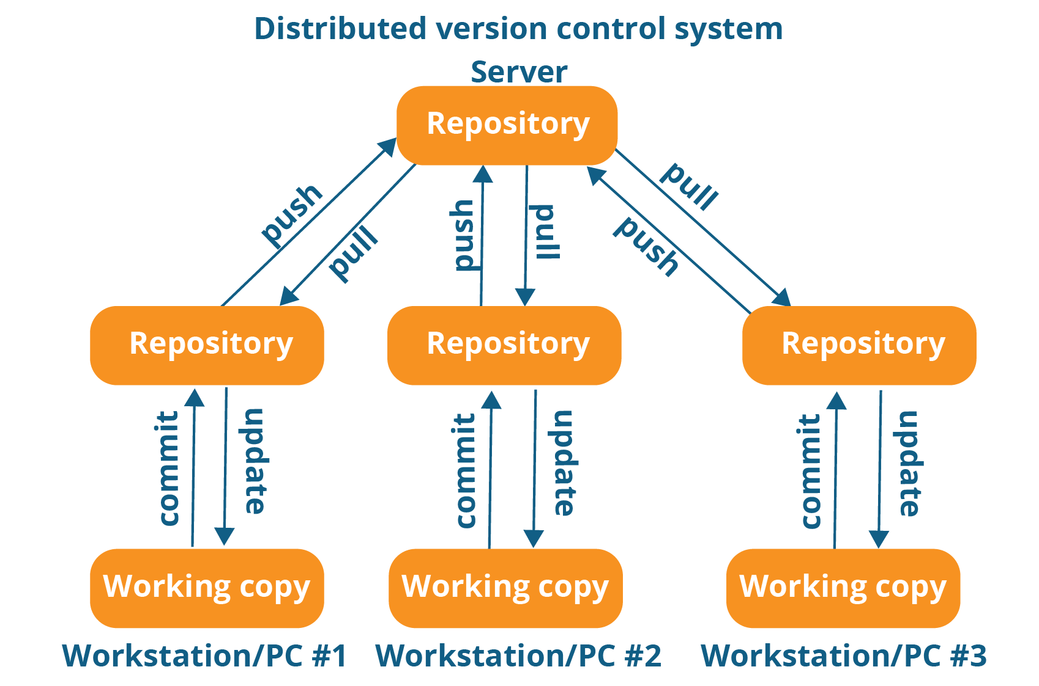

Terminologies in GIT:
- Repository: A Git repository is a place where Git stores all the versions of your project's files and directories.
- Working Directory: Where you see files physically and can do modification.
- Staging Area (Index): The staging area is an intermediate area where you can selectively choose which changes to include in your next commit.
- Commit: A commit is a snapshot of your repository at a specific point in time. It records the changes made to the local repository.
- Commit Id/Version-Id: Reference to identify each change.
- Snapshot: Represent some data of particular time. It is always incremental i.e., It stores the changes only, not the entire data.
- Tag: Tag assign a meaningful name with a specific version in the Repository. It's used to mark significant points in a project's history, such as releases or milestones.
- Pull: Pulling is the process of retrieving changes from a remote repository to a Local Machine.
- Push: Pushing is the process of sending your local changes to a remote or Central (global) repository.
- Server: It stores all Repositories.
- Branch: A branch in Git is a parallel version of a code-base that enables multiple developers to work on different aspects of a project simultaneously.
- Master (Main) Branch: The master (or main) branch is the default branch in GIT, and it typically represents the latest stable version of the project.
- Fork: Forking a repository creates a copy of it under your account, allowing you to make changes independently of the original repository.
- HEAD: It is a symbolic reference to the currently checked out branch or commit. It represents your current working state.

GIT Workflow and Architecture:
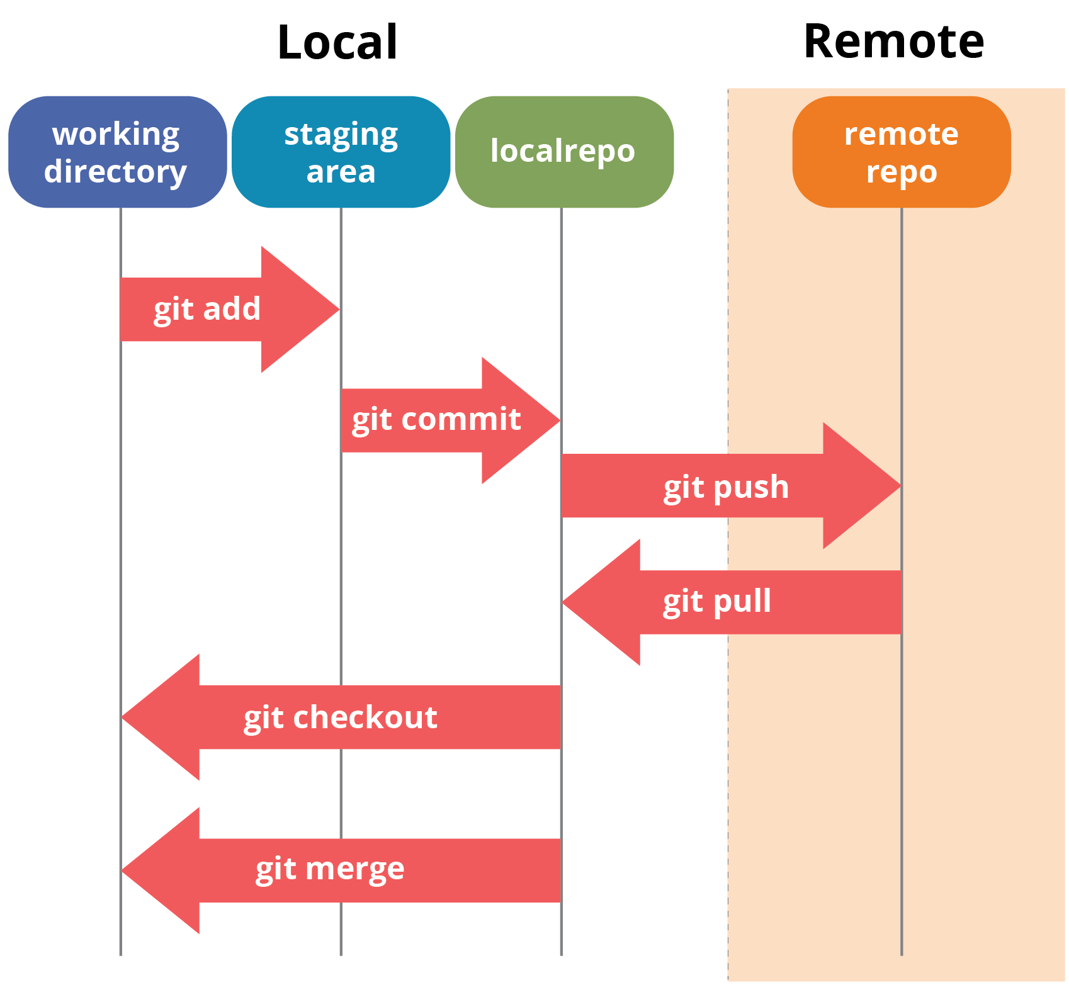
GIT Important Commands:
- Git Config: This command sets the author name and email address to be used with your commits.
- Git init: This command is used to initialize a local repository.
- Git add: This command is used to add one or more files to staging (Index) area.
- Git commit -m: This command create snapshots of the file permanently in the version history with a message.
- Git Status: The status command is used to display the state of the working directory and the staging area.
- Git push: This command is used to upload local repository content to a remote repository.
- Git pull: This command is used to receive data from GitHub. It fetches and merges changes on the remote server to your working directory.

GIT Branching, Tagging and Merging:
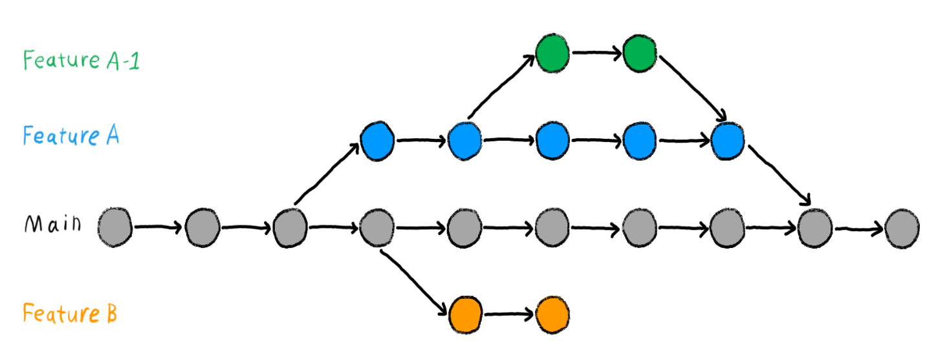
- Branching in Git allows you to create separate lines of development for features, bug fixes, or experiments, while keeping your main codebase (usually in the master branch) stable.
- To Create a new branch: git branch new-feature
- To Switch to the new branch: git checkout new-feature
- Git tagging is a way to mark specific points in your Git history, often used to identify releases or important milestones in the project.
- Merging in Git is the process of combining changes from one branch into another. This is commonly used to integrate feature branches into the main codebase i.e., to master branch.
Advantages of using GITHUB:
- Free and Open Source:- Its free and Open Source Service.
- Fast and Small:- As most of the operations are performed locally, therefore it is fast.
- Security:- git uses a common Cryptographic hash function called Secure hash function(SHA1), So it’s very Secure.
- No-need of Powerful Hardware:- With Git, we can easily work with large codebases, collaborate with other developers, and manage complex branching and merging workflows, all without needing a powerful machine.

GIT Commands
Basic Commands
git init : initialize a empty GIT repository (a Hidden Directory/Folder with name .git)
used to create a new GIT repository. When you run this command, GIT sets up the necessary structures and files in the current directory, allowing you to start tracking changes.
In .git folder, GIT generates several important files and subdirectories, including:
- HEAD: A reference to the current branch.
- config: Configuration settings for the repository.
- description: A brief description of the repository (used by GitWeb).
- objects: Directory to store all the objects (blobs, trees, commits).
- refs: Directory to store pointers to commit objects for branches and tags.
git status:
It is used to display the state of the working directory and the staging area. It shows which changes have been staged (GREEN color), which have not, and which files (RED color) are not being tracked by GIT. This command is important for understanding the current status of your project and for making informed decisions about your next steps.

git add <file-name>:
It is used to add specific file in your working directory to the staging area.
The staging area, also known as the index, is where you prepare a snapshot of your project’s current state before committing it to the repository.
git add . : Staged new and modified files without deleting. The dot(.) operator will take all the files and add them to the staging area.
git add -a : Staged all files to the staging area.
git add -u : Staged modified and deleted files.
git rm --cached <file-name>: To remove the file from the staging area.
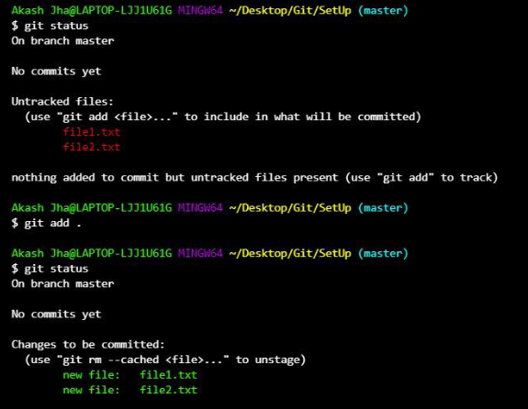
git config user.name <username> & git config user.email <email id>:
To check who has committed the code, we will use these commands.
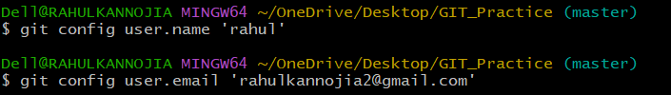
git commit:
Commit process involves recording snapshots of your project at various stages, allowing you to track progress, revert changes, and collaborate with others efficiently.
git commit –m “<commit message>” file-name: committing the specific staged file.
git commit –m “<commit message>” : committing all the staged files.
git commit –amend –m “<updated commit message>” : If some latest commit has been made into the repository that is not yet pushed to the upstream repository on GitHub and if you think that the commit message is incorrect we can edit or amend the commit message
git commit: It will open a window to write commit message, after writing that message we can close that window by Esc :wq
git log:
To check all the commits and its commit ids.
git log --oneline: to check all the commits in short form.
GIT Branching
git checkout <commit id/branch name>:
If we want to switch to a specific commit or branch, we will use this GIT command.
git branch:
If we want to check current branch, we will use this command. Like: git branch
git branch <branch-name>: to create a new branch, we will use this command.
Like: git branch b1
git branch -r : To check all branches that exist on your remote repositories.
git branch -a : To check both your local branches and all remote-tracking branches.

# create a branch from specific commit
Step-1. Identify the Commit Hash using git log.
Step-2. Create a new branch using "git branch <new-branch-name> <commit-hash>"

#Create a branch from a feature branch:
1. Ensure you are on the correct base branch, switch to the feature branch from which you want to create the new branch.
git checkout your_feature_branch_name
2. Create and switch to the new branch.
git checkout -b your_new_branch_name
(OR)
Alternatively first create new branch, then checkout to New Branch
- Creating New Feature Branch:
git branch <your_new_branch_name> <your_feature_branch_name>
b. Switching/ Checkout to New Branch: git checkout <your_new_branch_name>

GIT Remote Repositories
https://www.geeksforgeeks.org/git/handling-repositories-with-git-remote/
# Add a Remote Repository: git remote add origin <remote-repo-URL>
To establish a connection between your local repository and a remote repository.
# View Remote Repository: git remote -v
To display a list of linked remote repositories along with their URLs for the local system user attempting to connect to a GitHub server.
Remote Repositories Setup Management:
Commands | Descriptions
git remote add <name> <remote-url> | Adds a new remote repository (e.g.,name= origin)
git remote -v | Shows all remotes and their fetch/push URLs
git remote rename <old> <new> | Renames an existing remote
git remote remove <name> | Removes a remote from the local repository
git remote show <name> | Shows detailed info about a remote (branches, URLs, etc.)
git remote set-url <name> <new-url> | Updates the URL of an existing remote
Working with Remotes Repositories:
Commands | Descriptions
git clone <url> | Clones a remote repository to your local machine,
git fetch <remote> | Fetches changes from the remote without merging
git pull <remote> <local-branch> | Fetches and merges changes from a remote branch
git push <remote> <local-branch> | Pushes your local branch to a remote branch
git push --set-upstream origin <branch> | Sets upstream for tracking and pushes branch to remote

Remote Repositories Branch Handling:
Commands | Descriptions
git branch -r | Lists all remote-tracking branches
git checkout --track origin/<branch> | Creates a local branch tracking a remote branch
git push origin --delete <branch> | Deletes a branch from the remote repository
git remote prune origin | Removes references to deleted branches from the remote

# git clone vs git pull:
git clone <branch-URL> is for initial setup to get a local copy of a remote repository.
git pull is for ongoing updates to keep your local repository synchronized with the remote.
Renaming the Branch name:
Renaming a GIT branch involves a few steps, especially if you need to update both your local and remote repositories.

1. Rename the Local Branch:
- If you are on the branch you want to rename:
git branch -m new-branch-name
(The -m flag stands for "move" or "rename")
- If you are on a different branch:
git branch -m old-branch-name new-branch-name
2. Update the Remote Repository:
- Push the new branch to the remote:
git push origin -u new-branch-name
(The -u flag sets the upstream tracking branch for the new branch)
- Delete the old branch from the remote:
git push origin --delete old-branch-name
How to Rename a Branch in GIT:
We can rename the local branch in just one command without having to use git checkout.
Step 1: Make sure you are in the master/main branch
To check if you are in the master/main branch, run git status:
If you are not in the master/main branch, then you will need to run git checkout master or
git checkout main.
Step 2: Use the -m flag to rename the branch
You can use this syntax to rename the old branch to something new.
git branch -m old-branch new-branch
This is what it would look like to rename the test-branch to test-branch2.
git branch -m test-branch test-branch2
To see your new branch name, you can run git branch which will list all of your branches.
GIT Fork:
In Git, a fork refers to a personal copy of another user’s repository. When you fork a repository, you create an independent copy that exists within your own account or organization. This copy includes
- All the files
- commit history
- Branches present in the original repository at the time of forking.
Step-by-Step Guide to Fork a Repository:
Step 1: Navigate to the Repository
- Open the repository we want to fork on GitHub.
- We will see a Fork button in the top right corner of the repository page.
Step 2: Click on the Fork Button
- Click Fork to create a copy of the repository in the GitHub account.
- We can see python/cpython. This means python is the maintainer and cpython is the project's name.
Step 3: Confirm the Fork
- After forking, we will see the repository under the account.
- The repository name will appear as the-username/repository-name.
- The original repository link will still be available under the forked repository
- Find the Fork button in the top right corner.

Git Merge vs Git Rebase:
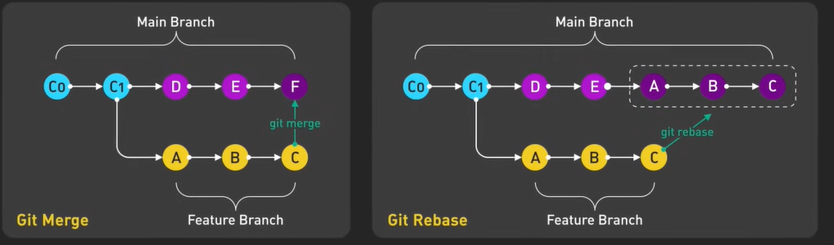

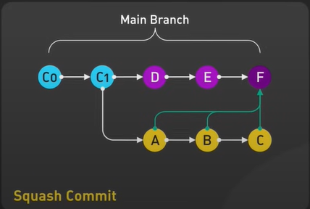

When this came
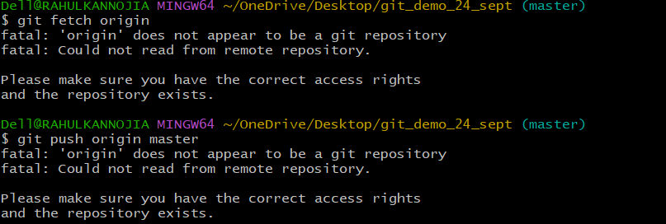
We solve like this
